Light Takes Over: Breakthrough Optical Array Revolutionizes Computing
By SPIE--International Society for Optics and PhotonicsNovember 2, 2024
Large-scale optical programmable logic array for two-dimensional cellular automata. Credit: Wenkai Zhang (Huazhong University of Science and Technology), edited
Optical computing aims to replace electricity with light to achieve faster, energy-saving computing.
Researchers have now developed an optical programmable logic array (PLA) that overcomes key hurdles, running advanced logic operations like Conway’s Game of Life. This breakthrough showcases optical computing’s future potential.
For years, researchers have explored ways to use light for computing, seeking faster speeds and reduced energy consumption compared to conventional electronic systems. Optical computing, which relies on light instead of electricity for calculations, offers promising advantages like high parallelism and efficiency. However, implementing complex logic functions with light has been challenging, limiting its practical applications.
A Breakthrough in Optical Logic Arrays
Now, researchers at Huazhong University of Science and Technology, along with the Wuhan National Laboratory for Optoelectronics, have made a significant breakthrough in this field. As reported in Advanced Photonics, they have developed a large-scale optical programmable logic array (PLA) capable of handling complex computations. This optical PLA leverages parallel spectrum modulation to achieve an 8-input system, greatly enhancing the scope of optical logic operations.
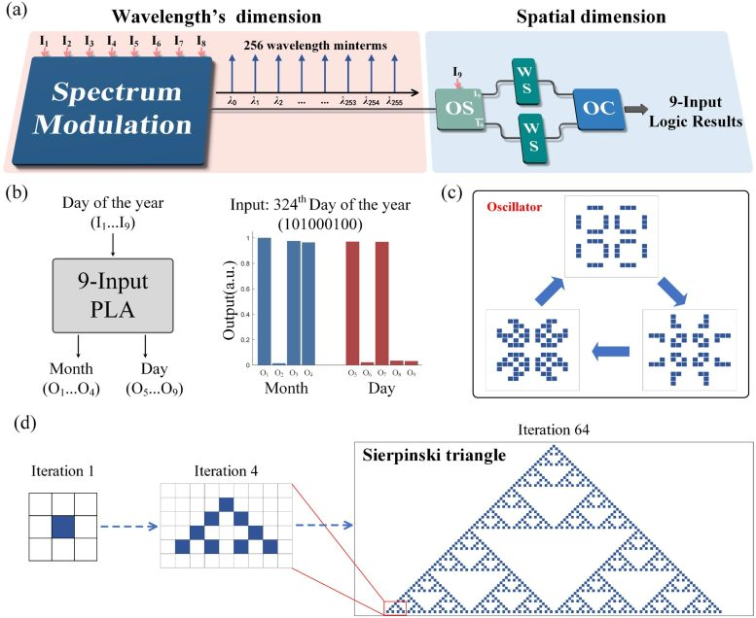Demonstration and application of large-scale optical programmable logic array. (a) Nine-input PLA realized by combining wavelength and spatial dimensions. (b) Statement machine to infer the date (month and day) according to the provided day of the year based on 9-input PLA. (c) Oscillator (pulsar) in Conway’s Game of Life. (d) Nonisotropic evolution, in which a single-cell pattern can create the Sierpinski triangle by two-dimensional cellular automaton. Credit: W. Zhang, B. Wu, et al., doi 10.1117/1.APN.3.5.056007
Running Complex Models on Optical Platforms
The researchers demonstrated the potential of their optical PLA by successfully running Conway’s Game of Life, a well-known two-dimensional cellular automaton. This achievement marks the first time such a complex model has been executed on an optical platform without relying on electronic components for nonlinear computing. The optical PLA’s ability to handle advanced logic functions, such as decoders, comparators, adders, and multipliers, showcases its versatility and potential for broader applications in digital computing.
Advancing Optical Computing for Future Applications
This innovative work not only advances the field of optical computing but also provides a new platform for simulating complex phenomena. The researchers’ success in running various cellular automata models, including the Sierpinski triangle, highlights the optical PLA’s capability to support intricate computational tasks. This development represents a significant step forward in the quest to leverage light for more efficient and powerful computing solutions.
Reference: “Large-scale optical programmable logic array for two-dimensional cellular automaton” by Wenkai Zhang, Bo Wu, Wentao Gu, Junwei Cheng, Hailong Zhou, Dongmei Huang, Ping-kong Alexander Wai, Liao Chen, Wenchan Dong, Jianji Dong and Xinliang Zhang, 17 October 2024, Advanced Photonics.
DOI: 10.1117/1.AP.6.5.056007

